Financial Management for IT Services
WHY:
The IT services market can be divided by the primary methods of purchases made by end-users and service providers:
- Discrete — Project-specific contractual arrangement, with a predetermined scope of work to be completed within a given time period
- Outsourcing — Annuity-based contractual arrangement that details how an organization will provision services on an ongoing basis at a specified level of competency. Outsourcing arrangements usually last between two and five years, but may be either shorter or longer.

In both cases it is vital to have a Financial Management process implemented. Control of IT spending is fundamental to the effective and efficient running of an IT Organisation.

GOAL:
- To provide cost-effective stewardship of the IT assets and resources used in providing IT Services
The aims for any IT Services organisation should include:
- To be able to fully account for the spend on IT Services and to be able to assign these costs to the services delivered to the organisation's Customers
- To assist management decisions on IT investment by providing detailed cost analysis regarding changes to IT Services

ACTIVITIES:
- Budgeting is the Process of predicting and controlling the spending of money within the organisation and consists of a negotiation cycle to set budgets (usually annual) and the day-to-day monitoring of the current budgets
  - Incremental budgets (build on last year’s budget)
  - Zero based budgets (start from scratch every time)
- IT Accounting is the set of processes that enable the IT organisation to account fully for the way its money is spent (particularly the ability to identify costs by Customer, by service, by activity). It usually involves ledgers and should be overseen by someone trained in accountancy
  - Direct Cost vs. Indirect Cost
  - Capital Cost (GCA) vs. Operational Cost (GST)
  - Fixed Cost vs. Variable Cost
  - Cost Types (e.g. Hardware, software)
  - Cost Elements (e.g. PC, Local Service within the cost type ‘hardware’
  - Cost Unit (chargeable unit)
- Charging is the activity required to bill Customers for the services supplied to them. To achieve this requires sound IT Accounting. The detail required must be pre-determined.

  - Charging Policy (Pricing) –derived from corporate charging system:
    - Cost Price
    - Cost Price +
    - Going Rate
    - Market Price
    - Fixed Price

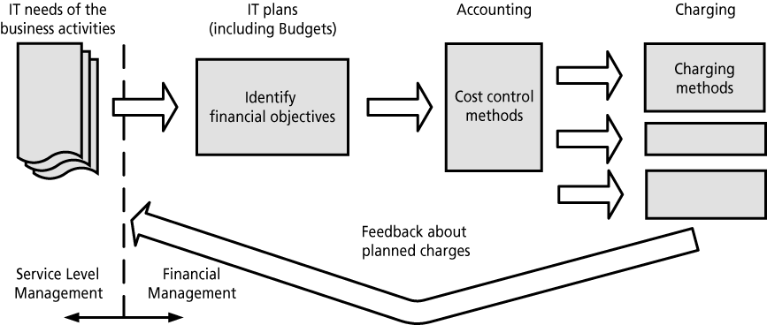
Terminology:
Accounting Centre: Simply costing inputs with maybe some elements of budgeting (no billing)
Recovery Centre: Account fully for all IT spend and recover costs from the customer
Profit Centre: The IT organisation operates as a separate business unit
Notional Charging: To create cost-awareness without the physical exchange of money

RESULTS:
Clear, accurate budgets
Management report on real Costs and Charges
Pricelist (to be added to Service Catalogue)

COST:
The costs associated with Budgeting, IT Accounting and Charging fall into 3 broad categories:
1) Staff: administration for Financial Management
2) Extra hardware and book keeping software
3) Support Tools
Once costs are visible, and particularly when Real Charging is in place, the demand for some services may fall. This results in reduced revenue but is not really a cost of implementation, as it is in the organisation's interest to identify and reduce inefficient use of IT resource.

BENEFITS:
- Increased confidence in setting and managing budgets
- Accurate cost information to support IT investment decisions
- Accurate cost information for determining cost of ownership for ongoing services
- A more efficient use of IT resource throughout the organisation
- Increased professionalism of staff within the IT organisation.

